Rushing to Inter-Ac Glory
In Inter-Ac League football history, eight players have rushed for at least 3,000
career yards. This page celebrates their feats -- Chris Downs, Malvern Prep, '98;
Alex Holcombe, Germantown Academy, 2007; Ibraheim Campbell, Chestnut Hill
Academy, 10; Edward Saydee, Penn Charter, '19; Paul McKinney, Haverford
School, '01; Rashad Campbell, Chestnut Hill Academy, '08; Dave Stilley,
Haverford School, '92; Matt Blewitt, Germantown Academy, 1998.
Note: Ibraheim and Rashad Campbell are brothers. Rashad's totals include only
CHA's two seasons of Inter-Ac membership during his high school career . . .
CHA is now known as SCH Academy (following a merger with its sister school,
Springside Academy.)
Return to TedSilary.com Home Page
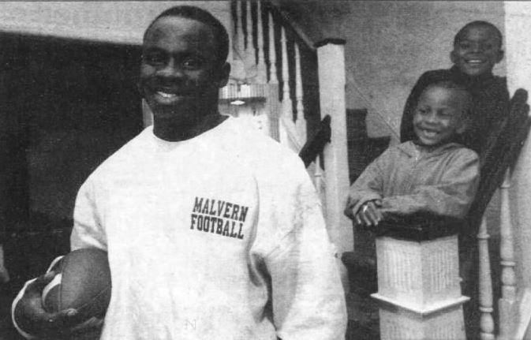
Malvern Prep's Chris Downs in 1997 with his nephews Ryan Beverly (top), and Sean Beverly.

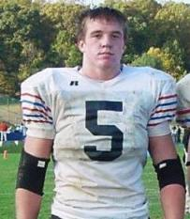  Alex Holcombe  Germantown Academy | 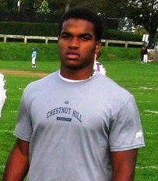  Ibraheim Campbell  Chestnut Hill Academy | Malvern's Chris Downs . . .  Leader of the Pack  This story about Chris Downs, the leading career rusher in Inter-Ac League history, was written during his senior season in 1997 . . .  By Ted Silary  Chris Downs has heard the story so many times, he almost can use the exact same words each time to retell it.  How his father, Dee, showed up for practice with a semipro football team in Sharon Hill on Aug. 31, 1955.  How he realized when he reached the field that one of his cleats was still in the trunk of his car.  How he returned to his car and saw two women standing nearby.  How he spoke to one and . . .  Forty-two years, eight children and 10 grandchildren later, Dee and Joan Downs are still together, living near 61st and Cobbs Creek in Southwest Philadelphia, and football is still a major part of their life.  The primary attention these days is being focused on Chris, a 5-9, 175-pound senior at Malvern Prep who last Saturday became only the second player in Inter-Ac League history to lift his career rushing total over 3,000 yards.  There is also Tony, a senior (but younger than Chris) who starts at defensive back for Malvern. There is also Derrick, a redshirt freshman who is seeing some action at running back for the University of Delaware and is expected to challenge for a starting spot next season. In 1995, he was a first-team Daily News All-City selection at defensive back.  There is also this thought: If not for the missing cleat . . .  ``When he came out to that car and started fumbling around, looking for his other football shoe, that amused me,'' Joan Downs said. ``I was thinking, `This guy must be a nut. He didn't even bring two shoes? ' ''  Said Chris: ``He probably `lost' it on purpose. I think something was up. ''  Chris Downs was laughing when he said that. Then again, when isn't he?  If there's one thing Chris Downs does better than run a football, it's enjoy life. In fact, to call him happy-go-lucky is to make a gross understatement.  Ask Chris whether he's surprised by his success and he chuckles.  Ask him whether there's someone in the pros he admires and he chuckles.  After a while, one begins to wonder whether someone who appears to be so filled with sunshine can possibly possess the eye of the tiger.  Phew, does he ever.  Downs last season set an Inter-Ac rushing record with 1,682 yards and this season he likely will blow that number away. Already, he has carried 149 times for 1,260 yards and 16 touchdowns for coach Gaspare ``Gamp'' Pellegrini's Friars (6-1), who have four games remaining.  Last Saturday, Downs rushed 38 times for 298 yards and a touchdown against Germantown Academy and added another score on an 87-yard kickoff return. His career  continued right below . . .
Top Game Performances by the Inter-Ac League's
Leading Career Rushers (In Order of Appearance Below)
Paul McKinney, Haverford School; Ibraheim Campbell,
Chestnut Hill; Chris Downs, Malvern; Rashad Campbell,
Chestnut Hill; Edward Saydee, Penn Charter;
Alex Holcombe, Germantown Academy; Matt Blewitt,
Germantown Academy; Dave Stilley, Haverford School.
Name | Opponent | Car. | Yards | Year
McKinney | Chestnut Hill | 18 | 316 | 2000
I. Campbell | Gtn. Academy | 32 | 310 | 2008
Downs | Carroll | 36 | 308 | 1997
Downs | Gtn. Academy | 38 | 298 | 1997
McKinney | Tatnall (DE) | 26 | 296 | 2000
R. Campbell | Pius X (Roseto) | 20 | 288 | 2006
Saydee | Gtn. Academy | 25 | 277 | 2018
Downs | Penn Charter | 28 | 276 | 1996
Holcombe | Haverford School | 40 | 267 | 2006
I. Campbell | Episcopal | 12 | 266 | 2009
Downs | Owen J. Roberts | 33 | 265 | 1996
McKinney | Oxford | 10 | 264 | 1998
Downs | Haverford School | 24 | 264 | 1996
Holcombe | Chestnut Hill | 53 | 258 | 2006
Holcombe | Pius X (Roseto) | 36 | 252 | 2006
I. Campbell | Haverford School | 41 | 251 | 2008
R. Campbell | Lower Moreland | 26 | 246 | 2006
Blewitt | Episcopal | 13 | 243 | 1997
Blewitt | Pennington (NJ) | 21 | 235 | 1996
I. Campbell | Haverford School | 39 | 234 | 2009
Stilley | Penn Charter | 48 | 231 | 1991
I. Campbell | Wood | 33 | 230 | 2009
Saydee | Upper Dublin | 22 | 226 | 2018
Downs | WC East | 27 | 226 | 1997
Holcombe | Haverford School | 24 | 225 | 2004
R. Campbell | Episcopal | 41 | 224 | 2006
Blewitt | Valley Forge MA | 29 | 218 | 1997
Downs | Episcopal | 28 | 216 | 1997
Holcombe | Haverford School | 27 | 215 | 2005
Downs | WC Henderson | 22 | 215 | 1997
Downs | Penn Charter | 21 | 214 | 1997
Saydee | SCH Academy | 28 | 213 | 2016
Stilley | Roman | 31 | 210 | 1990
I. Campbell | Haverford School | 22 | 201 | 2008
Holcombe | Episcopal | 39 | 200 | 2006
Downs | Chester | 34 | 200 | 1997

totals show 384 carries, 3,107 yards, 37 rushing TDs and 41 total TDs.
``I'm kind of surprised by all this,'' Downs said. ``You can't expect to do this much. ''
Downs, the reigning Inter-Ac champion in the three sprint events, exhibits a blend of grace, savvy and breakaway speed. On a typical run, Chris places his hand on the lower back of fullback Dan Bonner as he begins, looking, looking, looking. Then, he darts toward an opening, adds a shake and/or bake and zooms downfield. If no hole exists, he burrows into the pile to at least get something.
Chris is receiving mail from the likes of Michigan, West Virginia, Rutgers, Pittsburgh, Miami, Missouri, Indiana and Villanova, but he has no idea who's calling.
``My mother handles the phone calls,'' he said. ``She doesn't permit me to talk with them. And she doesn't tell me who's calling. I'm not really sure why she does that, except that she thinks it's best for my future. She did the same thing with Derrick. ''
Dee and Joan Downs have eight children ranging from 40 to 17: Robin, Deborah, Donna, Lonnie, Steven, Derrick, Chris and Tony. Steven starred in football at Penn Wood High and Central State (Ohio).
``I've been a football fanatic since I was a kid,'' Joan said. ``We've always been a football family. Now, we're passing it on to our grandkids. ''
The one thing Chris wants to do more than anything else is work in animation for Disney.
``This might sound kind of funny,'' he said, chuckling, ``but I'm a cartoonist. I can draw really good Disney characters - Mickey, Goofy, etc. Sometimes, I sell them to my friends and classmates. Or I give them to my girlfriends. ''
Girlfriends, plural?
``Yeah,'' Downs said. ``I don't charge them. I just give them the sketch and say, `Here you go. ' ''
He laughed.
``They get the special ones.'
--

