Malvern FB Commitments
Return to TedSilary Home Page
Six senior members of Malvern Prep's 2008 football squad have reached agreements to continue their careers in college: Mike Mayock (Newtown Square) at Villanova; Rob McCabe (Newtown Square) at Georgetown; Michael McCorkle (West Chester) at New Haven; CJ Mooney (Chester Springs) at Penn; Bobby Panchisin (Exton) at Army Prep, with Army to follow; and Joe Price (Havertown)at Villanova.
**Photos by Jim Mack.**

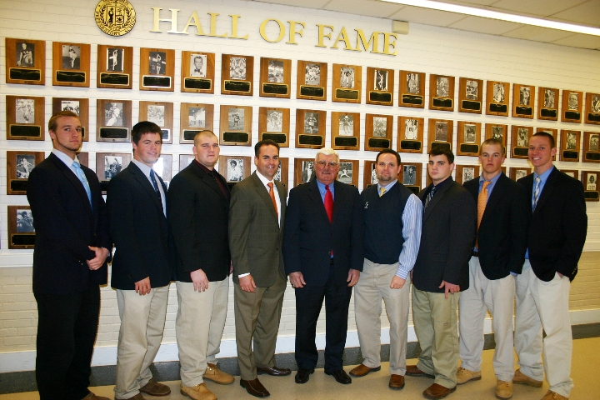
CJ Mooney, Rob McCabe, Bobby Panchisin, assistant Kevin Pellegrini (head coach for '09), coach Gamp
Pellegrini, assistant Kevin Whitney, Michael McCorkle, Mike Mayock and Joe Price.
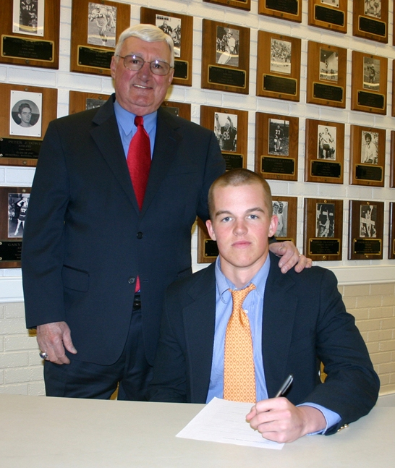
Gamp, Mike Mayock.
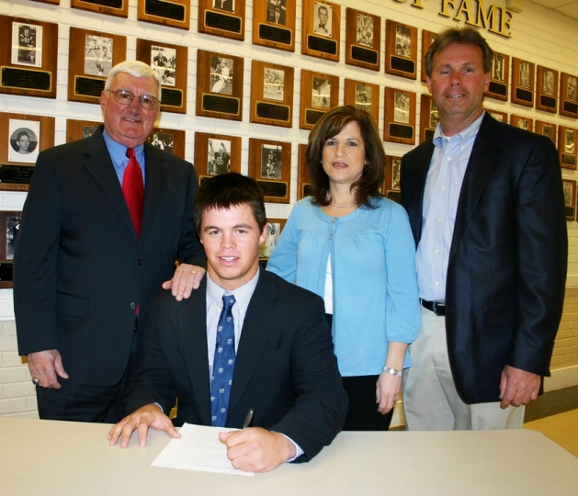
Gamp, Rob McCabe, mom Teresa and dad Nick.
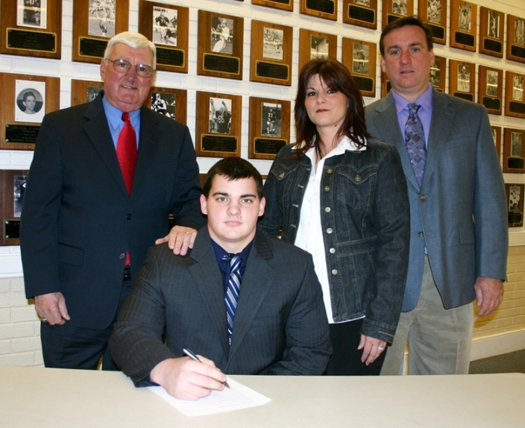
Gamp, Michael McCorkle, mom Donna, dad Mike.
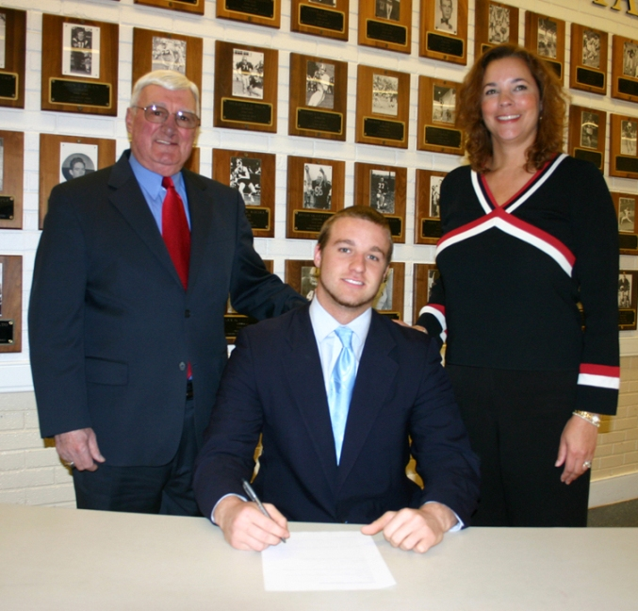
Gamp, CJ Mooney, mom Diane.
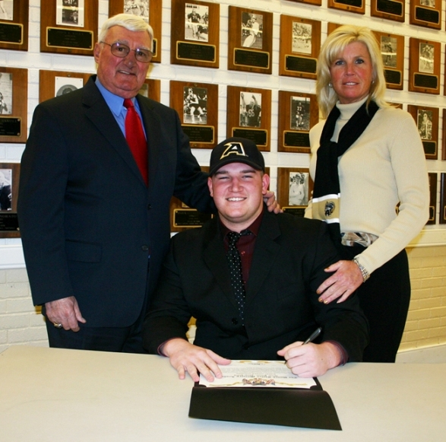
Gamp, Bobby Panchisin, mom Sharon Stevenson.
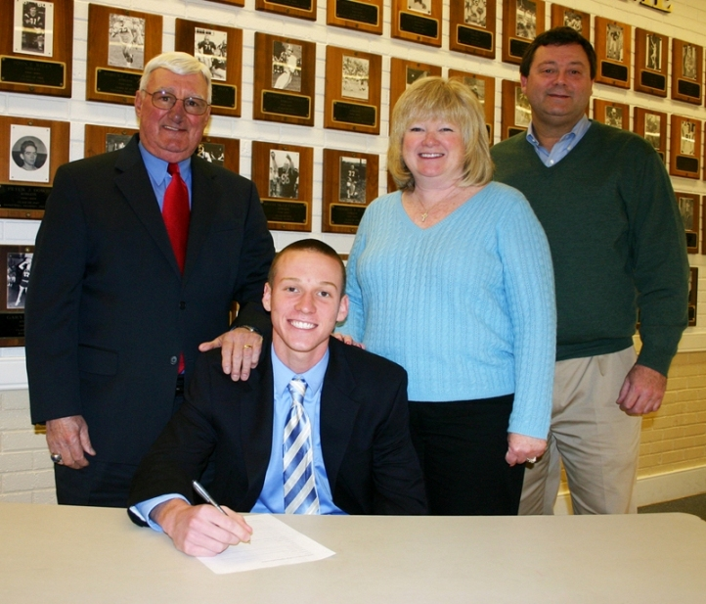
Gamp, Joe Price, mom Joanmarie and dad Joe.

